“How To” for Project RESPECT Classroom Observation
Data Collection

You will be using two Go Pro Hero cameras to collect classroom observation data before and after the Project RESPECT professional development:
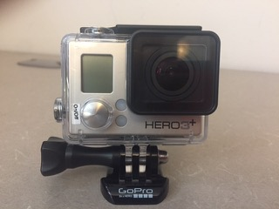

Before your assigned day/class period:

- Select two locations in your classroom for the Go Pro Cameras
  - Best locations include:
    - Somewhere high, such as on top of a filing cabinet or bookcase, and out of the reach of students
    - Somewhere away from speakers (of projectors)
    - Two different angles that capture most of your classroom

On your assigned classroom observation day/class period:

- Take cameras out of your data collection box before the start of the assigned period.
- Place cameras in pre-selected locations in your classroom.
- Press the on/off button.

- The display above the on/off button will appear like this:

*** Although the settings should default to video, please make sure that the icon in the display above the on/off button shows the video icon as shown below. If the icon does not show, press the on/off button to cycle through different modes (e.g., camera, time lapse) until the video icon appears.

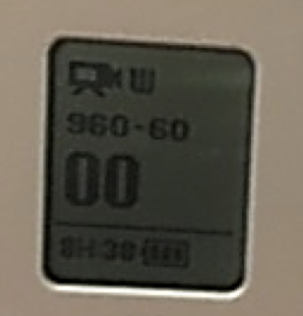

- Next, press the start/stop button on the top of the camera to begin recording. This should be done as students arrive and before the start of any instruction.

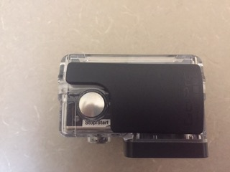

***You will know the camera is recording because the display on front will be counting up. Also, a red video icon will show on the display on the back of the camera.
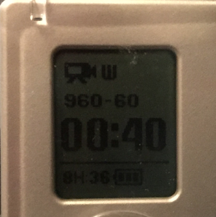

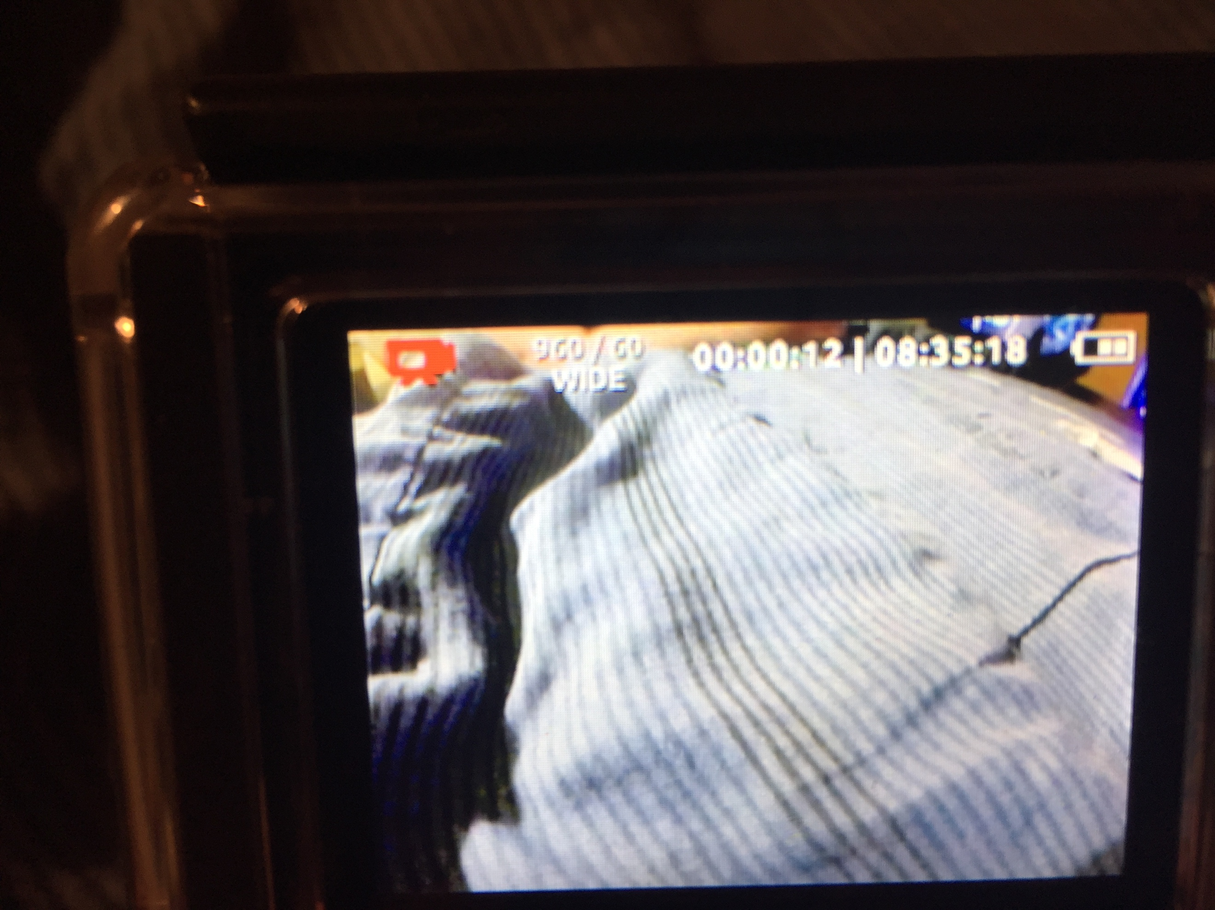

- At the end of class period, simply press the start/stop button to end the recording.
- Press and HOLD the on/off button for 3 seconds to turn off the camera.
- Place cameras in your data collection box.
- Place the box near your classroom door and a Project RESPECT team member will come by and collect it!

